**Profit forecast report**

Among the top 10 enterprises, Maotai, as a liquor enterprise, has the least impact on its profits from non-dispersible risks such as the COVID-19 epidemic, so its profit forecast model is more accurate.

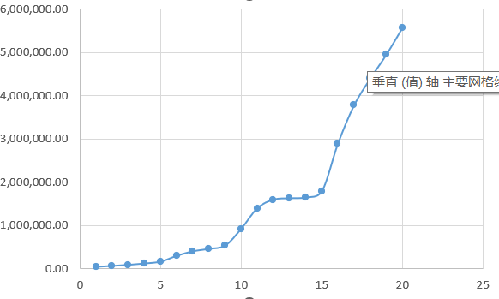

Figure I. X-Y Scatter Chart of Historical Net Profit Data of Moutai

Selecting the original data of net profit in the profit statement and simply drawing the X-Y scatter diagram can intuitively and clearly reflect that the trend of net profit in Maotai is nonlinear, and its graph does not conform to the log function image, so linear prediction, moving average prediction and nonlinear index prediction are excluded, and the exponential smoothing prediction scheme is adopted here.

Set the initial smoothing constant as 0.1, 阻尼系数为0.9, the data on December 31, 2003 in the column of forecast data is the same as the historical data at the end of the previous year, so the forecast value on December 31, 2004 is the historical data at the end of the previous year * smoothing constant + (1-smoothing constant) * forecast data at the end of the previous year. Pull down the formula to the forecast data at the end of 2022-12-31 to be forecasted.

Then the ()函 of SUMXMY2 is used to calculate MSE, and the optimal smoothing constant is solved to minimize the target value of MSE, and the smoothing constant is about 1.72639. At this time, the trend chart of historical data and predicted data can be drawn to be basically consistent, which can verify that the profit prediction model is effective, and the net profit of Maotai enterprises will continue to rise.

Figure II. Exponential smoothing profit forecast

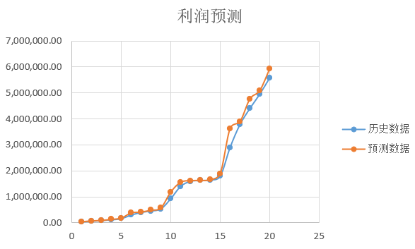

Figure III. X-Y Scatter Chart of Profit Forecast and Historical Value